1. **Introduction**

Effective stock management is essential for NGOs to deliver consistent, high-quality care to animals while maximizing limited resources. This project aims to develop a reliable system for tracking and managing essential veterinary supplies and medications, enabling the NGO to reduce waste, ensure critical items are available when needed, and streamline daily operations for both paid staff and volunteers.

1. **Objectives and Scope**

What are we going to assess during the project:

• Improve stock control of critical veterinary supplies.

•Minimize supply shortages and reduce expired stock.

•Simplify the tracking process for part-time and voluntary staff.

Scope:

•Initially track injected medications, daily-use medications, and essential veterinary supplies.

•Include processes for counting, tracking, and updating stock levels.

Supplies that we are going to track:

* Medications;
* Animal food;
* Cleaning products;
* Veterinarian supplies.

**Clarify Key Processes and Metrics for Tracking**

To ensure accuracy in stock tracking, consider detailing a standard procedure, such as:

* **Tracking Process**:
  + Implement a daily or weekly count of key medications and supplies.
  + Record details like units remaining, batch numbers, expiry dates, and donation sources.
  + Create a system for staff to record usage consistently.
* **Metrics**:
  + Current stock levels per item.
  + Frequency of use and average usage rate.
  + Donation frequency for each type of supply.

**Summing up and tracking the data**

First we need to track the data, count how many units of an specific medication there is, the size of that unit, how many were bought or received as a donation, and if they are close to the expiration date or not. In this project we are only going to track the name of the medications, the size of their respective units and how many were used in a certain period of time.

There are going to be broken numbers, such as “0,70” meaning the unit is not full, so we use and estimation of the availability.

Medications

1. Injecting medications

**Antibiotics**: Used to treat bacterial infections.



**Painkillers**: To reduce pain.

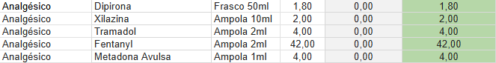

**Anti-inflammatories**: To reduce inflammation and pain.



**Vaccines**: Protection against specific diseases (e.g., rabies, distemper).

**Anesthetics**: For surgical and diagnostic procedures.



**Hormones**: Used in specific treatments (e.g., contraceptives).

**Supplements**: Vitamins and minerals that can be injected.

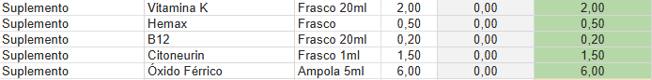

2. Oral medications

The most important thing to maintain an NGO working is the workforce it requires to help the animals and the humans who make it work. With that workforce we can always keep on helping animals and providing a good environment where everything works. Which is why possessing funds to pay for that workforce is what makes a difference when sustaining those operations.

Understanding the business is of most importance to better comprehend how to installs processes that will possibly help daily job operations. It is important to distinguish what is actually possible to be done to the veterinary team and administration, and what is not going to be helpful. One of the goals of this project is to implement activities and assess what is going to help the team and the administration and improve the daily work of paid workers and voluntary jobs.

When starting this project, there was a need to establish with the veterinary team what procedures where going to actually improve the work and help keep the supply stock organized. With that in mind and knowing that the veterinary team works part time, the decision was that